 | 
COUNCIL ASSESSMENT REPORT
HUNTER AND CENTRAL COAST REGIONAL PLANNING PANEL

PANEL REFERENCE & DA NUMBER | PPSCHCC-275 – DA/2317/2023  PAN-391916 (CNR -64057)
PROPOSAL | Construction and operation of an Asphalt Batching Plant (bitumen pre-mix and hot-mix facilities) and Waste or Resource Recovery Facility and associated works.
ADDRESS | Lot 410, DP 1058215  3 Warren Road Warnervale
APPLICANT | Rob Dwyer - SLR Consulting
OWNER | Wyee Asphalt P/L
DA LODGEMENT DATE | 21 Dec 2023
APPLICATION TYPE | Designated Development and Integrated Development
REGIONALLY SIGNIFICANT CRITERIA | Section 5 Schedule 6 of the SEPP (Planning Systems) 2021: Waste or Resource Management Facilities over $5 million
CIV | $13,644,186 (excluding GST)
CLAUSE 4.6 REQUESTS | N/A
KEY SEPP/LEP | SEPP (Planning Systems) 2021  SEPP (Resilience and Hazards) 2021  SEPP (Transport and Infrastructure) 2021  SEPP (Industry and Employment) 2021  SEPP (Biodiversity and Conservation) 2021  SEPP (Sustainable Buildings) 2022  Central Coast Local Environmental Plan 2022
TOTAL & UNIQUE SUBMISSIONS KEY ISSUES IN SUBMISSIONS | None
DOCUMENTS SUBMITTED FOR CONSIDERATION | EIS and Architectural and civil plans
SPECIAL INFRASTRUCTURE CONTRIBUTIONS (S7.24) | No, however, S7.11 and productivity contributions apply
RECOMMENDATION | Approval
DRAFT CONDITIONS TO APPLICANT | No
SCHEDULED MEETING DATE | 18 November 2024
PLAN VERSION | 14 November 2024
PREPARED BY | Principal Development Planner (Salli Pendergast)
DATE OF REPORT | 18 November 2024

EXECUTIVE SUMMARY

The proposal is for the construction and operation of a new Asphalt Batching Plant (bitumen pre-mix and hot-mix facilities) and Waste or Resources Management Facility with a production capacity of 225,000 tonnes per annum (tpa) of asphalt.
The proposal satisfies the definition of ‘general industry’ and resource recovery facility which are both permissible uses with consent in the E4 zone under Central Coast LEP 2022.
The proposal is classified as Designated Development under Section 4.2(1) of the Environmental Planning and Assessment Act 1979 (EP&A Act) and the NSW Department of Planning & Environment has issued Secretary’s Environmental Assessment Requirements (SEARs). The development is also integrated development requiring approval for a licence from the Environment Protection Authority (EPA) as a ‘scheduled activity’ under the Protection of the Environment Operations Act 1997.
Schedule 1, Section 34 of the Protection of the Environment Operations Act 1997 requires an Environmental Protection Licence (EPL) to carry out a scheduled activity for waste storage. General Terms of Approval for issue of an Environmental Protection Licence (EPL) has been granted by the EPA (Notice No. 1636393 dated 21 May 2024).
The development will have a waste storage capacity of processed Recycled Asphalt Products (RAP) of up to 500t at any one time and storage capacity of unprocessed RAP of up to 1,000t at any one time, noting no RAP processing will occur. Crumbed rubber will be stored for up to 100t at any one time. The site would operate 24 hours a day, seven days a week.

Jurisdictional prerequisites to the grant of consent have been satisfied with regard to:

- Section 4.6 of the Resilience and Hazards SEPP for consideration of whether the land is contaminated;
- Section 2.122(3) and Section 2.48(2) of the Transport and Infrastructure SEPP in relation to traffic-generating development and in relation to development likely to affect an electricity transmission or distribution network (respectively).
- Section 4.9 of (Chapter 4) Koala Habitat Protection 2021 of SEPP (Biodiversity & Conservation) 2021
- Section 3.2(2) – Development consent for non-residential development of SEPP (Sustainable Buildings) 2022
- Clause 5.22 (Flood planning), Clause 6.2 (Public Utility Infrastructure) and Clause 7.6 (Essential Services) of CCLEP 2022
The application was placed on public exhibition for 30 days from 9 February 2024 until 12 March 2024. There were no submissions received from the notification/advertising of the proposal.

- THE SITE AND LOCALITY

  - The Site

The site is located on the southern side of Warren Road, with a north-easterly facing frontage, 50m east of Burnet Road. The site is within the established Warnervale Business Park, is vacant industrially zoned land (zone E4 – General Industrial) and slopes away from the road frontage. The site size is 10,931m² in area. The site is approximately 200m from Sparks Road and 700m from the Warnervale Interchange of the M1 Pacific Motorway.

The site is identified as bushfire prone land and is located within the Wyong Employment Zone Urban Release Area.

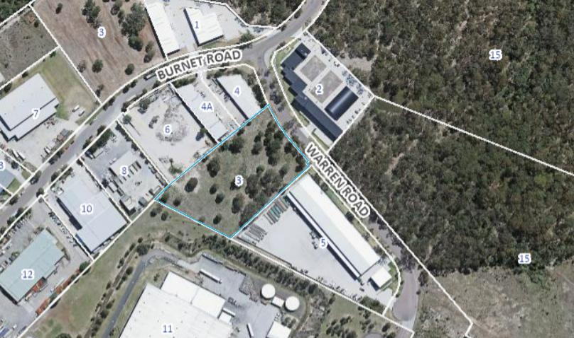
Above: Aerial view of site

  - The Locality

The site is located within an established industrial area, readily accessible from Warnervale Interchange of the M1 Pacific Motorway.

Adjoining the side boundaries of the site is varied industrial development and to the rear boundary is the Woolworths distribution centre. Further beyond this, is a mix of bushland buffer (surrounding the business park), other industrial land (north and east), Warnervale Airport (east) and the M1 motorway (west).

There are residential receivers approximately 400m to the north of the site on the opposite side of Sparks Road. The closest residentially zoned land (zoned R5) is the large lot residential land located on the opposite (western) side of the motorway over 600m distance away and is not readily visible from the site.

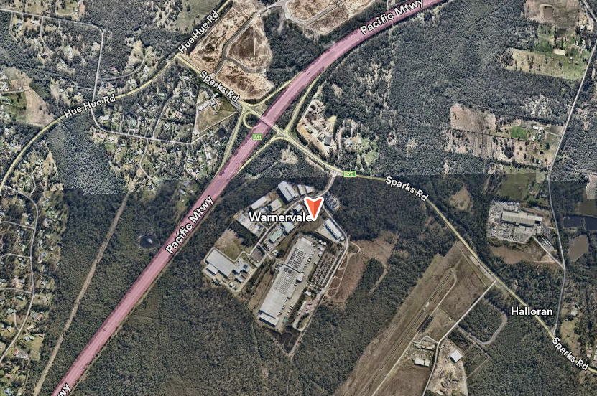
Above: View of site context

- THE PROPOSAL AND BACKGROUND

  - The Proposal

The development application is seeking approval for the construction and operation of an Asphalt Batching Plant (bitumen pre-mix and hot-mix facilities) and Waste or Resource Management Facility within a vacant industrial site at 3 Warren Road Warnervale.
The proposal is classified as Designated Development under Section 4.2(1) of the Environmental Planning and Assessment Act 1979 (EP&A Act).

The proposal also includes the construction and operation of associated development including:
- Construction of a 2-story batching room with a small, attached office, a laboratory and amenities comprising a concrete slab, foam cladding walls with a render finish and sloping roof (172.3m² in area).
- Extensive hard stand areas for parking (9 spaces) and for the storage and loading of asphalt, raw materials, and bitumen.
- Construction of roofed raw product storage bins (10) (333.9m² & 176.5m²).
Construction of roofed crumbed rubber storage bins (131.5m²) and unprocessed RAP storage bins (119.3m²).
Various tanks (bitumen tanks, emulsion tanks, a diesel tank, an ‘ad blue’ tank, and a hydrated lime silo.
- External lighting and fencing including a 3.6m high masonry wall is proposed to the site frontage and a 3.6m soundproof panel fence is proposed adjacent to the side and rear boundaries.
- Stormwater system.
- Landscaping works
The proposal also includes bulk earthworks, construction of retaining walls, connection of utilities and services, installation of plant and other lighting, other fencing and line marking, water tanks, construction of a sediment basin for stormwater run-off and vehicle access. Access is via 2 separate driveway crossovers to Warren Road for separated ingress and egress with a 10m wide access to accommodate 26m long B-Double design vehicles.

The site will operate 24 hours a day and 7 days a week.

The Asphalt Batching Plant (bitumen pre-mix and hot-mix facilities) will have a production capacity of asphalt of 225,000 tonnes per annum (tpa) including:
o 25,000 TPA of crumb rubber asphalt products.
o 50,000 TPA of slag asphalt products.
o 25,000 TPA recycling capacity of Recycled Asphalt Products (RAP).

The proposal includes components deemed to be a waste or resource management facility for the storage of waste (including processed Recycled Asphalt Products (RAP), unprocessed RAP and crumb rubber) and reuse of waste (including processed RAP and crumb rubber). In this regard, the development will have a waste storage capacity of processed RAP of up to 500t at any one time and storage capacity of unprocessed RAP of up to 1,000t at any one time, noting no RAP processing will occur. Crumbed rubber will be stored for up to 100t at any one time.

There would be approximately 15 employees during the construction phase. There are 10 Staff (full time equivalent (FTE)) for plant operation, as well as 5 truck drivers (FTE). There are also an additional 10 FTE truck drivers who may be subcontracted. Peak production and delivery times anticipated to occur between 7am to 2pm and 8pm to 1am but the site will operate 24 hours a day. Operational night lighting as well as spotlights fixed to plants and directional signage lighting are also proposed.

The additional storage activities on the site will include:
10 x aggregate storage bins (128m³).
4 x 20m³ and 1 x 30m³ hot storage bins, insulted and lagged.
3 x 80t bitumen tanks
2 x 60t emulsion tanks
1 x 60t diesel fuel tank
1 x 6t ‘ad blue’ tank
1 x 30m hydrated lime silo.

The operational processes include:

Aggregates, sand, bitumen, reclaimed asphalt pavement (RAP) and mineral filler (lime) are delivered to the site by truck. Raw materials are stored in designated areas prior to mixing. Aggregate materials and mix specifications are selected on a project-to-project basis then heated and dried. Aggregate materials are mixed with hot bitumen as per specifications on a project-to-project basis. Waste asphalt is recycled in accordance with production schedule and mix specification. Asphalt is dispatched from the site by covered trucks and 1 of the 5 load points (only 1 load point will operate at a time).

The proposal will generate general waste associated with the office and personnel on site. Solid waste material will be collected from the site via a contracted waste service on a standard collection cycle as required. Run-off from the new roof areas will be directed to the above ground rainwater tanks via a first flush device. Overflow will be connected to the piped network and discharging into a sediment basin located at the rear of the site. Stormwater drainage pits will be fitted with a filtration system for water quality. Subsoil drainage lines will be installed throughout the site which connect to the stormwater system. The bunded diesel fuel storage and unloading area will not connect to the stormwater network and any spills will be contained within the bunded area.

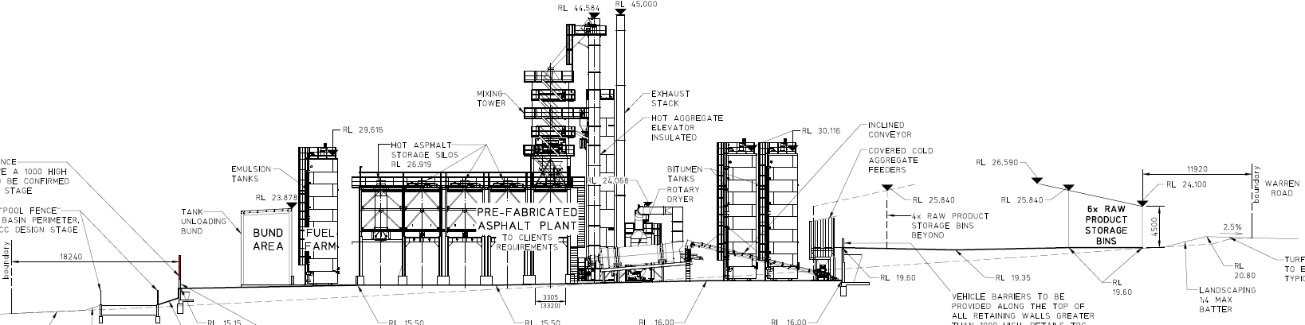
Above: Front - rear section through the site
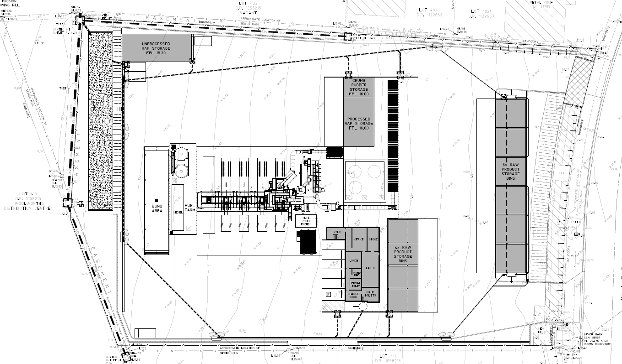
Above: Site Layout
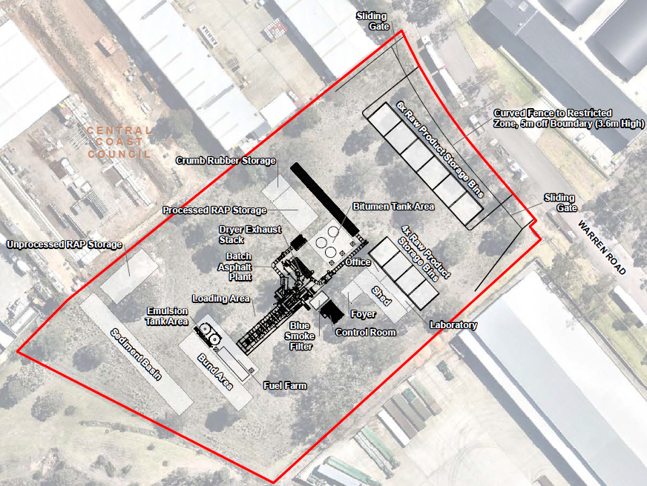
Above: Site layout and aerial photo overlay

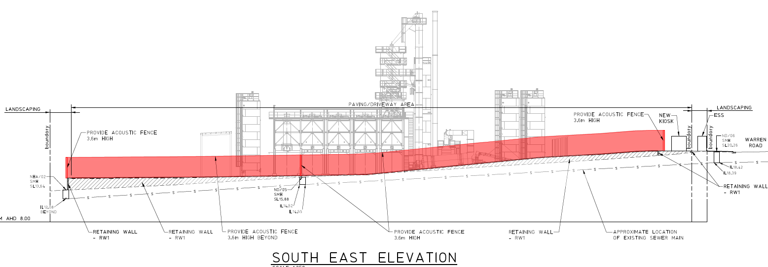
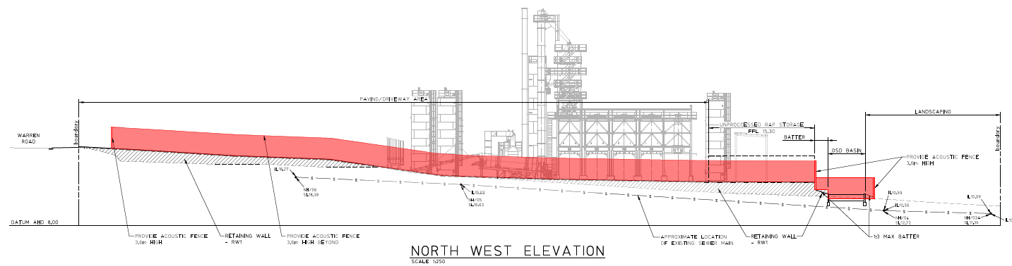

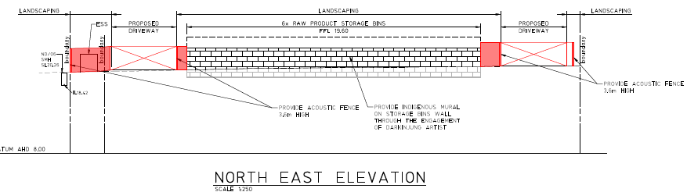
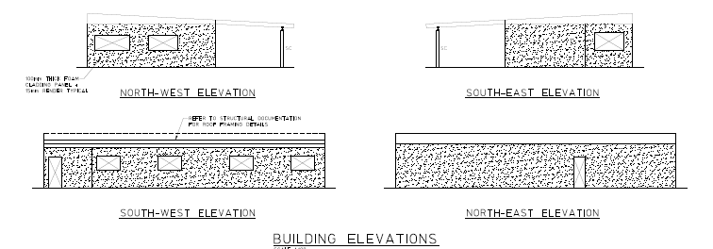
Above: Office and laboratory building
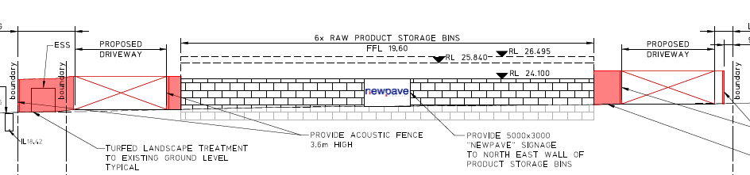
Above: North-east (front) elevation facing Warren Road
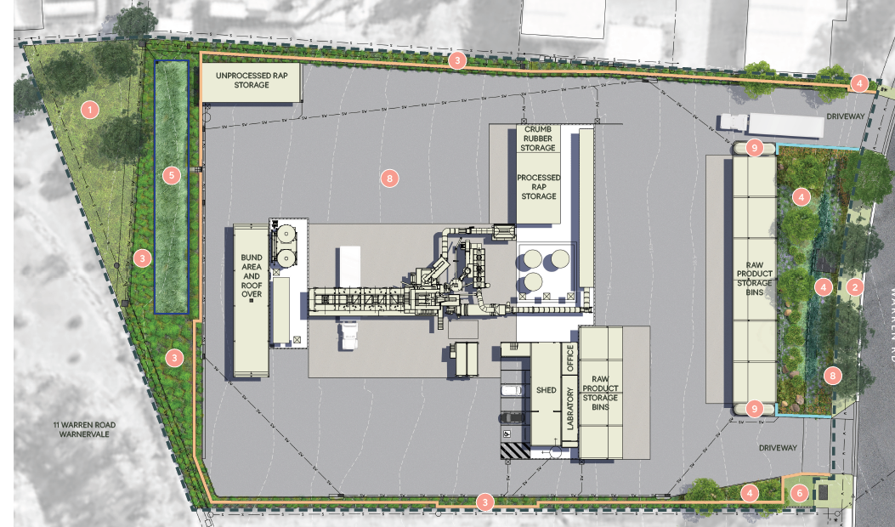
Above: Landscape Plan

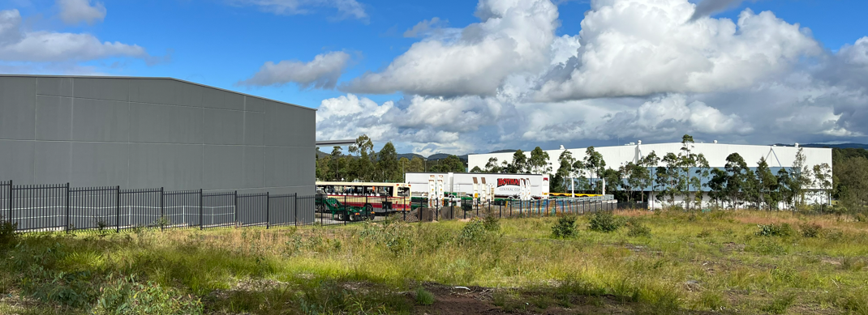
Above: View mid-way on-site looking south-east

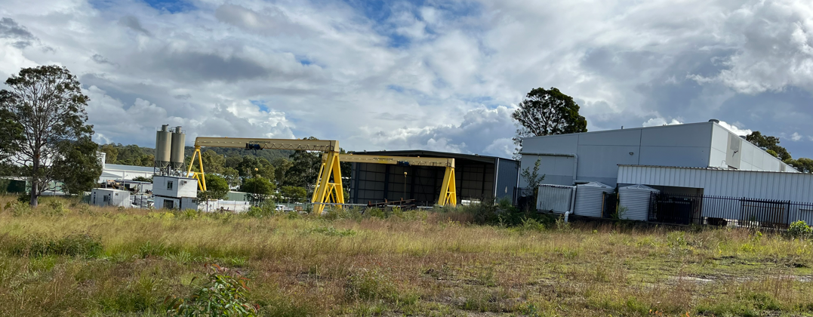
Above: View mid-way of site looking west (adjoining development rear half of site)

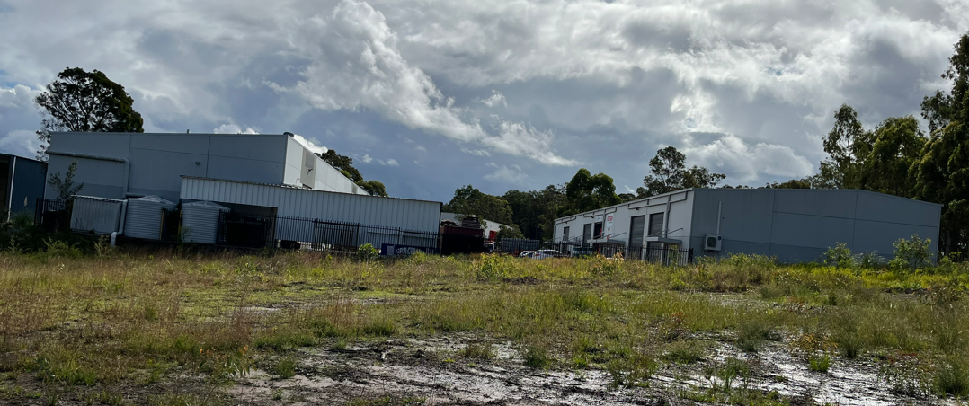
Above: View from on-site looking west (adjoining development front half of site)

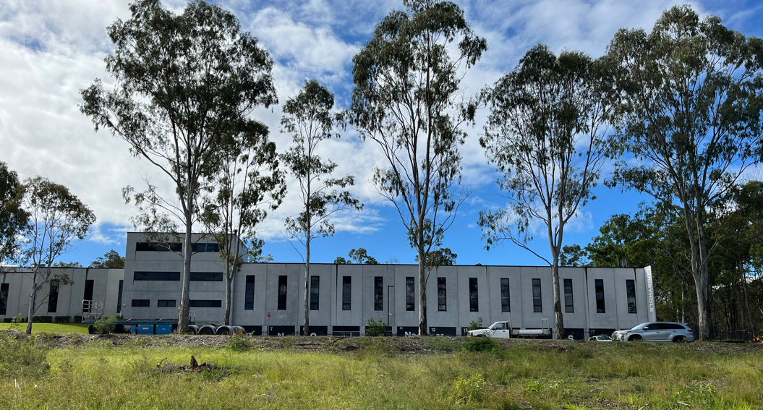
Above: View from on-site looking north-east towards street front showing existing street trees

Table 1: Development Data
Control | Proposal
Site area | 10,931m²
GFA | 172m² (office, foyer and laboratory)  761.2m² (storage bins)
FSR | 0.085:1  (Max 0.8:1 DCP Ch 2.9)
Max Height | 29m  DCP specified not visible above treeline on M1 and Sparks Road. A visual impact analysis provided.
Operating hours | 24 hours, 7 days a week
Production capacity | Production capacity of asphalt of 225,000 tonnes per annum (tpa) including:  o 25,000 TPA of crumb rubber asphalt products.  o 50,000 TPA of slag asphalt products.  o 25,000 TPA recycling capacity of Recycled Asphalt Products (RAP).
Waste storage capacity | - up to 500t - Processed RAP at any one time  - up to 1,000t - unprocessed RAP at any one time (noting no RAP processing will occur).  - up to 100t - crumbed rubber at any one time.
Parking | 9 spaces
Employees | Operation  10 FTE plus 5 FTE truck drivers (operation)  Additional 10 FTE truck drivers may be subcontracted as needed.  Construction  15 FTE (during construction)
Site coverage | Significant extent of hardstand area required for manoeuvring, loading and access. Soft landscaping (15% of site) has been provided to all site boundaries.  DCP requires hardstand areas to be minimised and augmented by soft landscaping.
Landscaped area | 10m landscaping along the front boundary.  1700m² soft landscaping (includes 540m² retained vegetation at rear corner)  DCP requires 10m front landscaping but does not specify other required landscaping
Car Parking spaces | 9 formal line marked parking spaces  Under DCP, no specified rate as merit consideration.
Setbacks | 10m front setback for storage bins  Min 1.9m western side  Min 6.8m eastern side  Min 5.7m rear  DCP Ch 2.9 requires:  -10m front  - Side/rear Nil/BCA compliance

  - Background

A pre-lodgement meeting was held prior to the lodgement of the application on 21 June 2023 where various issues were discussed.

Secretary’s Environmental Assessment Requirements (SEARs) were issued on the 3 July 2023 by the Industry Assessments Section of the Department of Planning and Environment (DPE). The SEARs identified key issues that must be addressed under the EIS as well as consultation. The details of the consultations required under the SEARs was addressed within Section 5 of the EIS. The SEARs were also accompanied by comments and information requirements from NSW Environment Protection Authority.

The development application was lodged on 21 December 2023. A chronology of the development application since lodgement is outlined below including the Panel’s involvement (briefings, deferrals etc) with the application:

Table 2: Chronology of the DA
Date | Event
7 July 2023 | Secretary’s Environmental Assessment Requirements (SEARs) issued
21 December 2023 | DA lodged
21 December 2023 | Exhibition of the application 12 January 2024 to 12 February 2024
9 February 2024 | Re- exhibition of the application (to correct description) 9 February 2024 until 12 March 2024
21 December 2023 | DA referred to external agencies.
27 January 2024 | Ausgrid comments received.
3 Jan 2024 | NSW RFS comments received
25 January 2024 | EPA requested information
27 February 2024 | Panel briefing
28 March 2024 | Transport for NSW requested information
16 April 2024 | Applicant provides information to EPA
9 May 2024 | Transport for NSW requested information.
21 May 2024 | NSW EPA issue General Terms of Approval
27 June 2024 | Request for Information from Council to applicant
29 July 2024  & 31 July 2024 | Amended plans and information provided including revised traffic assessment report.
7 August 2024 | Transport for NSW comments received for updated traffic report
18 September 2024 | Request for Information from Council to applicant
10 Oct 2024 | Amended plans and information lodged
13 Oct 2024 | Request for information from Council to applicant
14 Nov & 4 Dec 2024 | Amended plans and information lodged

  - Site Consent History

- DA/1344/2017 was granted on 21 February 2018 for high technology industry (Intensive Plant Agriculture, Pharmaceutical Laboratory & Processing Facility) at 3 Warren Road (lot 410 DP1058215), Warnervale. A privately issued Construction Certificate for early works (comprising construction of a retaining wall and associated works) was issued on 15 Dec 2023 and this was relied upon by the applicant for the clearing of the existing native vegetation on the site that has been carried out between Oct 2023 and Feb 2024.

- DA/875/2015 was granted on 22 December 2015 for Clearing of native vegetation on the site at 3-5 Warren Road (Lot 410 & 411 DP.1058215). Under Condition 1 the consent required the retention of all trees within 10m of the street frontage, all hollow bearing trees or trees with a breast height of greater than 40cm, and all trees within the habitat area subject to a restriction on use (Area J). The restriction on use on Lot 410 was extinguished on 20 Jan 2016. The clearing under this consent was not carried out and this consent lapsed 22 Dec 2017.

- A Pre-lodgement meeting PDA/105/2023 was held on 21 June 2023 for the proposed Asphalt Batching Plant and Waste or Resources Management Facility at 3 Warren Road, Warnervale.

- Planning Secretary’s Environmental Assessment Requirements (SEAR) 1780 were issued on 7 July 2023 for the construction and operation of an asphalt batching plant, operating at a production capacity of up to 225,000 tonnes per annum (tpa) of asphalt and a recycling capacity of 25,000 tpa of other asphalt products (crumbed rubber, crushed glass and constitute material at 3 Warren Road Warnervale (Lot 410 DP.1058215).

- STATUTORY CONSIDERATIONS

When determining a development application, the consent authority must take into consideration the matters outlined in Section 4.15(1) of the Environmental Planning and Assessment Act 1979 (‘EP&A Act’). These matters as are of relevance to the development application include the following:

- the provisions of any environmental planning instrument, proposed instrument, development control plan, planning agreement and the regulations
- the likely impacts of that development, including environmental impacts on both the natural and built environments, and social and economic impacts in the locality,
- the suitability of the site for the development,
- any submissions made in accordance with this Act or the regulations,
- the public interest.

These matters are further considered below.

It is noted that the proposal is considered to be (which are considered further in this report):

- Integrated Development (s4.46)
- Designated Development (s4.10)

Integrated Development

The development is integrated development requiring the issue of an Environmental Protection Licence (EPL) under the Protection of the Environment Operations Act 1997 (POEO Act) by the NSW Environment Protection Authority (EPA).

The type of licence under Section 43(b) of the POEO Act is to authorise the carrying out of scheduled activities at any premises, as required under section 48 (Licensing Requirement- scheduled activities (premises-based).

Under Schedule 1, Part 1, Section 34 (b) of the Protection of the Environment Operations Act 1997, the proposed resource recovery facility requires an Environmental Protection Licence (EPL) from the NSW EPA as it involves processing more than 6,000 tonnes of waste per year. The waste storage and recycling will incorporate slag, waste tyres (crumb rubber) and general solid waste (non-putrescible) as reclaimed asphalt. The development will have a waste storage capacity of processed recycled asphalt products (RAP) of up to 500t at any time and storage capacity of unprocessed RAP of up to 1,000t at any one time, noting no RAP processing will occur. Crumb rubber will be stored for up to 100t at any one time.

Resource Recovery
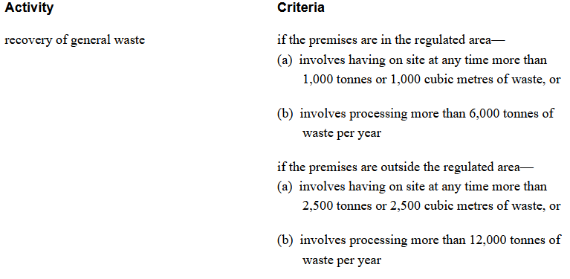
The NSW EPA granted their General Terms of Approval for issue of an Environmental Protection Licence (EPL) for the development on 21 May 2024 (Notice No. 1636393).

Designated Development

The proposal is declared to be designated development under Schedule 3, Part 2 of the EP&A Regulation with the following relevant definition.

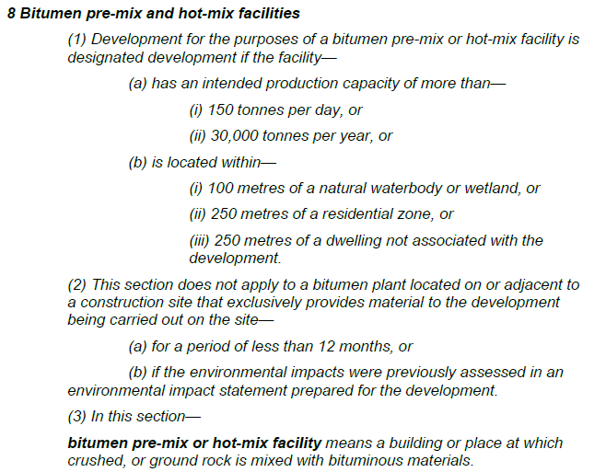

The development will be producing 225,000 tonnes of asphalt per annum and have a recycling capacity of asphalt products (RAP) of 25,000 tonnes per annum and therefore meets the above threshold for designated development under the Regulation 2021.

waste management facility or works means a facility or works that—
(a) stores, treats, purifies or disposes of waste, or
(b) sorts, processes, recycles, recovers, uses or reuses material from waste.

The proposal also contains components defined as a waste or resource management facility under Schedule 3 Section 45(6) of Schedule 3 (Part 2) of the Regulation but does not meet the thresholds to be declared designated for this use.

An environmental impact statement was prepared for the development in accordance with Section 4.12(8) of the Act and Planning Secretary Environmental Assessment Requirements (SEARS) were obtained (no.1780) in accordance with Section 173 of the Regulation 2021.

  - Section 4.15(1)(a)(i) - Provisions of Environmental Planning Instruments

The following Environmental Planning Instruments are relevant to this application:

- State Environmental Planning Policy (Planning Systems) 2021
- State Environmental Planning Policy (Biodiversity and Conservation) 2021
- State Environmental Planning Policy (Resilience and Hazards) 2021
- State Environmental Planning Policy (Industry and Employment) 2021
- State Environmental Planning Policy (Transport and Infrastructure) 2021
- State Environmental Planning Policy (Sustainable Buildings) 2022
- Central Coast Local Environmental Plan 2022

A summary of the key matters for consideration arising from these State Environmental Planning Policies are outlined in Table 3 and considered in more detail below.

Table 3: Summary of Applicable State Environmental Planning Policies
EPI | Matters for Consideration | Comply (Y/N)
SEPP (Planning Systems) 2021 | - Chapter 2 – State and Regional Development  Section 2.19(1) declares the proposal regionally significant development under Section 5 of Schedule 6 of the SEPP (Planning Systems) 2021: being a waste or resource management facilities over $5 million in value. | Y
SEPP (Resilience and Hazards) 2021 | - Chapter 3 - Part 3 – Hazardous and Offensive Development.  The proposed facility can be defined as a “potentially hazardous industry” and “potentially offensive industry” under Section 3.2. A Preliminary Hazard Analysis Report has accompanied the proposal which identifies that with adopted mitigation measures the proposal would not meet the definitions of hazardous or offensive industry.  - Chapter 4 – Remediation of Land  Section 4.6 (b) requires that consent not be granted until Council has considered whether the land is contaminated. If the land is contaminated, the Council needs to be satisfied that the land is suitable in its contaminated state (or will be suitable, after remediation) for the purposes for which the development is proposed to be carried out.  A Preliminary Site Investigation (contamination) was prepared for the proposal which has addressed the requirements of the SEPP (R& H) 2021. | Y  Y
SEPP (Industry and Employment) 2021 | - Chapter 3 Advertising and Signage  A flush wall business identification sign is proposed. | Y
SEPP (Transport and Infrastructure) 2021 | - Section 2.122 – Traffic Generating Development  The proposed waste or resource management facility and asphalt plant (bitumen pre-mix and hot-mix facilities) is identified as traffic generating development under Schedule 3.  Transport for NSW have provided comments based on the revised Traffic Impact Assessment raising no objection to, or requirements for, the proposed development.  - Subdivision 2 – Development likely to affect an electricity Transmission or distribution network - Section 2.48 Determination of DA’s- other development.  Ausgrid comments have been obtained raising no objection subject to conditions. | Y
SEPP (Biodiversity & Conservation) 2021 | - Chapter 4: Koala Habitat Protection 2021  Prior to granting consent, need to be satisfied whether or not the land is potential koala habitat and whether the development is likely to impact on koalas or koala habitat (s4.9).  The site is not considered to be core koala habitat and the development is not likely to adversely impact on koalas or their habitat. | Y
SEPP (Sustainable Buildings) 2022 | - Chapter 3- Standards for non-residential development  Development consent must not be granted to non-residential development unless the consent authority is satisfied the embodied emissions attributable to the development have been quantified.  The development complies with Section 3.2(1) & (2) for the granting of consent. | Y
CCLEP 2022 | - Permissibility  - Clause 4.3 - Height of buildings  - Clause 4.4 - FSR  - Clause 5.10 - Heritage  - Clause 6.2 - Public Utility Infrastructure  - Clause 7.1 - Acid sulphate soils  - Clause 7.6 - Essential services: | Y
CCDCP 2022 | - Ch 1.2 - Notification of Development Proposals  - Ch 2.9 - Industrial Development  - Ch 2.13 - Transport and Parking  - Ch 2.14 - Site Waste Management  - Ch 2.15 - Signage and Advertising  - Ch 5.38 - Warnervale – Business Park | Y

State Environmental Planning Policy (Planning Systems) 2021

- Chapter 2: State and Regional Development

State Environmental Planning Policy (Planning Systems) 2021 applies to the proposal as it identifies if development is regionally significant development. In this case, pursuant to s. 2.19(1), the proposal is a regionally significant development as it satisfies the criteria in Schedule 6 - Cl.5(a) ‘Private infrastructure and community facilities’ over $5 million being a waste or resource management facilities. The proposed development has a CIV of $13,644,186 (excluding GST).

Accordingly, the Hunter and Central Coast Regional Planning Panel is the consent authority for the application. The proposal is consistent with this Policy.

State Environmental Planning Policy (Resilience and Hazards) 2021

- Chapter 3 - Part 3 – Hazardous and Offensive Development.

The proposal has been assessed under the provisions of Chapter 3 of the SEPP to determine whether the development comprises a hazardous or offensive industry and is therefore prohibited. The SEPP applies to any proposed industry which requires consent and which falls under the policy’s definition of ‘potentially hazardous industry’ or potentially offensive industry’. The relevant definition s of which are:

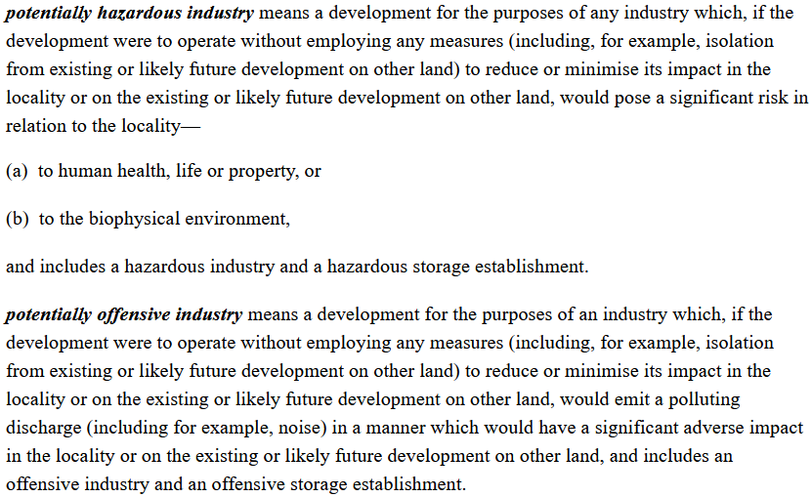

Section 3.7 of the SEPP requires that in determining whether a development is:
(a) a hazardous storage establishment, hazardous industry or other potentially hazardous industry, or
(b) an offensive storage establishment, offensive industry or other potentially offensive industry,

consideration must be given to current circulars or guidelines published by the Department of Planning relating to hazardous or offensive development.

These circulars and guidelines include the ‘Hazardous Industry Planning and Assessment Guidelines – Guideline Summary’ (NSW Planning Jan 2011) and ‘Applying SEPP 33 – Hazardous and Offensive Development Application Guidelines’ (Department of Planning 2011) and the Hazard Industry Planning advisory Paper series 1-12. The guidelines require that the assessment of a potentially hazardous industry should consider the findings of a preliminary hazard analysis as well as the likely future uses of the land surrounding the site and alternatives and justification for the proposal.

A Preliminary Hazard Assessment (20 October 2023) (PHA) was provided for the proposal which has considered the relevant circulars and guidelines and has been reviewed. The PHA identified the main dangerous goods potential hazards associated with the proposal included diesel (storage and transport) and heating of combustible materials during production operations.

The PHA concluded that the residual risks associated with these low hazards once controls are implemented were rated as tolerable (ie. risk is acceptably low). The risk of biophysical damage outside the site is considered unlikely based on the engineering and design controls that will be in place.

Hazardous substances and dangerous goods are stored and used at the asphalt plant,
include (at any one time):
- 70,000L ~ of Diesel – outdoor above ground tank – bunded with capacity of approx. 110% of storage tank
- Bitumen – 3 x outdoor above ground tanks with total capacity of 240t (3 x 80t bitumen tanks)

The preliminary hazard analysis has determined the general risk to people, property and the environment is low. Conditions will be recommended to comply with EPL.

- Chapter 4 – Remediation of Land
The provisions of State Environmental Planning Policy (Resilience and Hazards) 2021 (‘SEPP RH’) Chapter 3 (Remediation of Land) have been considered in the assessment of the development application.
Section 4.6 of the SEPP requires that consent not be granted until Council has considered whether the land is contaminated. If the land is contaminated, the Council needs to be satisfied that the land is suitable in its contaminated state (or will be suitable, after remediation) for the purposes for which the development is proposed to be carried out.

A Preliminary Site Investigation (contamination) (PSI) was prepared for the proposal which has addressed the requirements under SEPP (Resilience and Hazards) 2021 by considering the site history, undertaking a site investigation, and considering these to support any conclusions made within the PSI. The site is not listed as a notified or regulated contaminated site under the NSW Contaminated Land Management Act 1997. The PSI identifies that the site has been historically undisturbed with no developments occurring on the site. The areas surrounding the site have been progressively developed for general industrial purposes since 2005. Imported fill material was identified along the western boundary adjacent to the neighbouring site in 2016. No infrastructure for underground storage tanks or underground services were identified on the site. There were no indications of ground contamination including asbestos containing material. The report concludes that the contamination risk in relation to the development is considered to be low.

The PSI recommends a Construction Environmental Management Plan including an Unexpected Finds Protocol be prepared during works. The proposal is considered satisfactory subject to recommended conditions.

State Environmental Planning Policy (Biodiversity and Conservation) 2021

Chapter 4: Koala Habitat Protection 2021

The SEPP applies as the subject site is greater than 1 hectare in area and the land does not have an approved koala plan of management applying to it. Prior to granting development consent to carry out development on land to which the Chapter applies, the Council must assess and be satisfied as to whether the development is likely to have any impact on koalas or koala habitat (under Section 4.9(2) and (3)). However, under Section 4.9(5)(a)(ii) Council may grant consent if suitable information is provided demonstrating that the land is not core koala habitat. Council’s Ecologist has confirmed that no Koala feed trees will be removed. The land is not likely to be potential koala habitat and Council is satisfied that the development is likely to have low or no impact on koalas or koala habitat.

- Section 2.122 – Traffic Generating Development

The proposed waste or resource management facility component of the development (of any size or capacity with a frontage to a road- generally) is specified under Column 2 of Schedule 3 of SEPP (Transport and Infrastructure) 2021 as ‘traffic generating development’. The proposed development must not be carried out unless written notice of the application is given to Transport for NSW (TfNSW) and any response received within 21 days is taken into consideration.

In accordance with Section 2.122, the application was referred to TfNSW for comment who initially raised concerns and requested further information in relation to the traffic modelling.
Following submission of amended information, the application was referred to TfNSW who, based on the revised Traffic Impact Assessment, raised no objection to or requirements for the proposed development.

Section 2.122 (4) also requires that before determining a DA for development to which this section applies, the consent authority must take into consideration-

(ii) the accessibility of the site concerned, including—

(A) the efficiency of movement of people and freight to and from the site and the extent of multi-purpose trips, and

(B) the potential to minimise the need for travel by car and to maximise movement of freight in containers or bulk freight by rail, and

(iii) any potential traffic safety, road congestion or parking implications of the development.

Council’s Traffic and Transport Engineer has assessed the traffic impacts of the development and has reviewed the TfNSW response and has raised no objection. It is anticipated that the proposed development will not have a significant impact on the surrounding road network.

The proposal is considered satisfactory with regard to meeting the requirements of the SEPP.

- Subdivision 2 – Development likely to affect an electricity Transmission or distribution network - Section 2.48 Determination of DA’s- other development
Section 2.48 of the SEPP applies to the development and in accordance with subsection (2), before determining a DA to which the Section applies, the consent authority must give written notice of the application to the electricity supply authority for the area in which the development is to be carried out, inviting comments about potential safety risks, and take into consideration any response received within 21 days.
Ausgrid comments have been obtained raising no objection subject to conditions.

State Environmental Planning Policy (Industry and Employment) 2021

Chapter 3 – Advertising and Signage

The provisions of Chapter 3 (Advertising and Signage) SEPP (Industry and Employment) 2021 (SEPP IE) apply to the proposal. The proposed development seeks approval for new business identification signage associated with the development as follows:

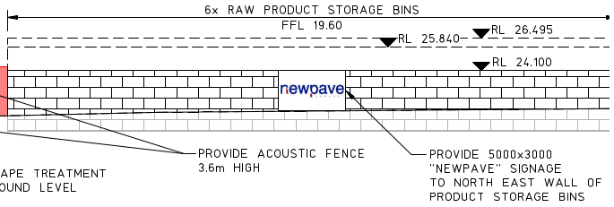

A flush wall business identification sign is proposed in the centre of the north-east wall of the product storage bins with the dimensions 5000mm x 3000mm depicting the name of the business operator on the site.

Under the SEPP IE, the signage would be considered as ‘business identification signs’ and as such, Part 3.3 of the SEPP does not apply to the development. Business identification signage is defined under the standard instrument as:

‘business identification sign’ means a sign:
(a) that indicates:
(i) the name of the person, and
(ii) the business carried on by the person,
at the premises or place at which the sign is displayed, and
(b) that may include the address of the premises or place and a logo or other symbol that identifies the business,
but that does not include any advertising relating to a person who does not carry on business at the premises or place.

In accordance with Section 3.6 of the SEPP, the proposed signage (subject to conditions) is considered to be consistent with the objectives of the policy (under Section 3.1(1)(a)) and satisfies the assessment criteria specified under Schedule 5 (Assessment criteria) of the instrument.

State Environmental Planning Policy (Sustainable Buildings) 2022

The DA was lodged after 1 Oct 2023 and therefore the relevant provisions of SEPP (Sustainable Buildings) 2022 apply. Chapter 2 (Standards for Residential development – Basix) does not apply. However, the proposed development exceeds $5 million in value, and the exemptions under Section 3.1(2) & (3) do not apply, therefore Chapter 3- ‘Standards for non-residential development’ is applicable.
In deciding whether to grant development consent to non-residential development, the consent authority must consider whether the development is designed to enable the following considerations under Section 3.2(1) (Development consent for non-residential development) included below.
(a) the minimisation of waste from associated demolition and construction, including by the choice and reuse of building materials,
(b) a reduction in peak demand for electricity, including through the use of energy efficient technology,
(c) a reduction in the reliance on artificial lighting and mechanical heating and cooling through passive design,
(d) the generation and storage of renewable energy,
(e) the metering and monitoring of energy consumption,
(f) the minimisation of the consumption of potable water.
Although the building component is small (office and laboratory), the proposal includes energy efficient building materials (including the reuse of building materials where possible). prescribed limits for lighting, power consumption, fan energy, a/c systems and hot water generation will be set for the office component.
It is considered that the development is designed to enable the above considerations outlined in Section 3.2(1) of the SEPP.
Section 3.2(2) states:

Development consent must not be granted to non-residential development unless the consent authority is satisfied the embodied emissions attributable to the development have been quantified.

The embodied emissions attributable to the development have been quantified as per the Embodied Emissions Report prepared for the development. The information required to populate the NABERS Embodied Emissions Materials Form has been collected including materials with high impact on embodied carbon (eg concrete and steel). The Embodied Emissions Materials Form and Report is certified by a suitably qualified professional.

The proposal has satisfied the requirements of Section 3.2(2) for the granting of consent.

Central Coast Local Environmental Plan 2022

The relevant local environmental plan applying to the site is the Central Coast Local Environmental Plan 2022 (CCLEP). The proposal is consistent with the aims of the LEP as the proposal will provide employment opportunities to meet the needs of existing and future residents and will foster economic growth so that the Central Coast continues to develop as a sustainable and prosperous place to live and work.

Zoning and Permissibility (Part 2)

The site is located within the E4 General Industrial zone pursuant to Clause 2.2 of the CCLEP.

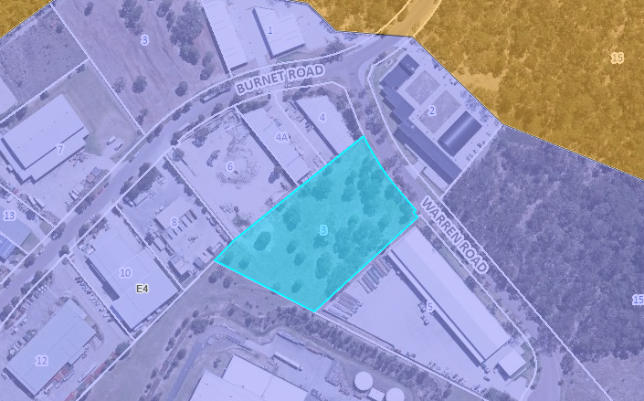
Above: Extract of zoning map from CCLEP showing site zoning

According to the definitions in Clause 4 (contained in the Dictionary), the proposal satisfies the definition of ‘general industry’ and ‘resource recovery facility’ which are both permissible uses with consent in the E4 zone. The relevant definitions under CCLEP are as follows:

general industry means a building or place (other than a heavy industry or light industry) that is used to carry out an industrial activity.
Note—
General industries are a type of industry—see the definition of that term in this Dictionary.

industrial activity means the manufacturing, production, assembling, altering, formulating, repairing, renovating, ornamenting, finishing, cleaning, washing, dismantling, transforming, processing, recycling, adapting or servicing of, or the research and development of, any goods, substances, food, products or articles for commercial purposes, and includes any storage or transportation associated with any such activity.

waste or resource management facility means any of the following—

(a) a resource recovery facility,

(b) a waste disposal facility,

(c) a waste or resource transfer station,

(d) a building or place that is a combination of any of the things referred to in paragraphs (a)–(c).

resource recovery facility means a building or place used for the recovery of resources from waste, including works or activities such as separating and sorting, processing or treating the waste, composting, temporary storage, transfer or sale of recovered resources, energy generation from gases and water treatment, but not including re-manufacture or disposal of the material by landfill or incineration.
Note—
Resource recovery facilities are a type of waste or resource management facility—see the definition of that term in this Dictionary.

The definition of heavy industry under CCLEP reads:

heavy industry means a building or place used to carry out an industrial activity that requires separation from other development because of the nature of the processes involved, or the materials used, stored or produced, and includes—

(a) hazardous industry, or

(b) offensive industry.

It may also involve the use of a hazardous storage establishment or offensive storage establishment.
Note—
Heavy industries are a type of industry—see the definition of that term in this Dictionary.

The development is not a heavy industry and, in this regard, a PHA was provided with the application which identified that development was not a hazardous or offensive industry. When in operation and when all measures are proposed to reduce or minimise its impact on the locality have been employed, the proposed development will not pose a significant risk in the locality to human health, life, or property, or to the biophysical environment.

The zone objectives include the following (pursuant to the Land Use Table in Clause 2.3):

• To provide a range of industrial, warehouse, logistics and related land uses.
• To ensure the efficient and viable use of land for industrial uses.
• To minimise any adverse effect of industry on other land uses.
• To encourage employment opportunities.
• To enable limited non-industrial land uses that provide facilities and services to meet the needs of businesses and workers.
• To ensure that retail, commercial or service land uses in industrial areas are of an ancillary nature.
• To support and protect industrial land for industrial uses.

The proposal is considered to be consistent with these zone objectives as it will provide an industrial land use that will provide employment opportunities and additional services and products to the broader area and will not result in adverse impacts to other uses.

General Controls and Development Standards (Part 2, 4, 5 and 6)

The LEP also contains controls relating to development standards, miscellaneous provisions and local provisions. The controls relevant to the proposal are considered in Table 4 below.

Table 4: Consideration of the LEP Controls
Control | Requirement | Proposal | Comply
Height of buildings  (Cl 4.3) | There is no height control under CCLEP applying to the site. | N/A | N/A
FSR  (Cl 4.4) | There is no FSR control under CCLEP applying to the site | N/A | N/A
Heritage  (Cl 5.10) | This clause requires consideration of both European and Aboriginal Heritage | The subject site is not in proximity to any European heritage items or heritage conservation areas. An AHIMS search as well as other data bases was undertaken, and the site is not in proximity to any recorded Aboriginal sites or declared Aboriginal places. | Yes
Flood planning (Cl 5.22) | The clause applies to all development. Consent cannot be granted unless the matters under Clause 5.22(3)(a)-(c) have been considered. | The site is not flood affected and is not considered to be land which in the event of a flood may cause a risk to life and require the evacuation of people or other safety considerations. | Yes
Public utility infrastructure (Cl 6.2) | Consent cannot be granted to development in an Urban Release Area unless public utility infrastructure (PUI) essential for the development is available or arrangements made for its availability. | The site is located within an Urban Release Area (Wyong Employment zone). More specifically within the established Warnervale Business Park and PUI essential for the development is available. | Yes
Acid sulphate soils  (Cl 7.1) | The site is not mapped for Acid Sulphate soils. | N/A | N/A
Airspace Operations (Cl 7.4) | The clause applies to development that will penetrate the Limitation or Operations Surface. | The site is not within the OLS area affected under the Warnervale Airport Obstacle Limitation Surface (OLS) Map. | Yes
Essential Services (Cl 7.6) | Consent must not be granted unless all of the essential services for the development are available or arrangements made for their availability including the supply of water and electricity, sewage disposal, stormwater drainage, vehicular access and waste collection. | The site is located within an established industrial business park and all these services are available. Sewer relining is required between Manhole NHA01 to Manhole NHA02. Building in the Proximity of Water & Sewer Pipelines procedure is applicable due to the proposed retaining wall. A section 307 certificate of compliance under the Water Management Act 2000 will need to be obtained. Water and Sewer contribution fees are applicable. | Yes

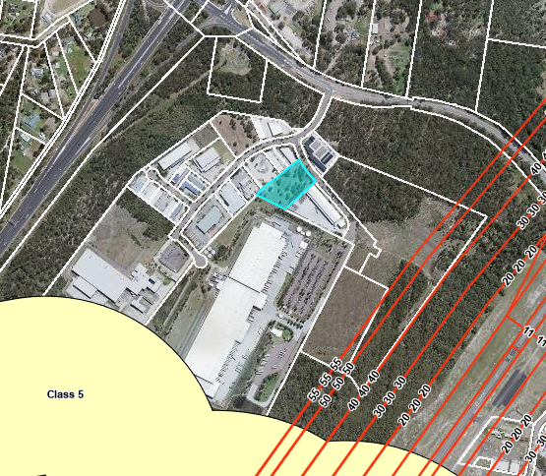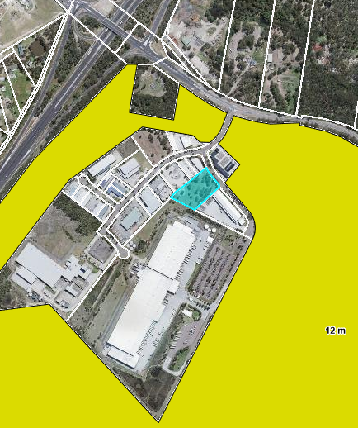
Above: CCLEP mapping for ASS and Aircraft OLS map (left) and Building Height (right)

The proposal is considered to be generally consistent with the LEP.

  - Section 4.15 (1)(a)(ii) - Provisions of any Proposed Instruments

There are no proposed instruments which have been the subject of public consultation under the EP&A Act, and which require discussion in relation to the proposal.

  - Section 4.15(1)(a)(iii) - Provisions of any Development Control Plan

The following Development Control Plan is relevant to this application:

Central Coast Development Control Plan 2022 (‘CCDCP’)

• CCDCP Chapter 1.2 – Notification of Development Proposals

The development application was notified in accordance with the DCP Chapter 1.2 and the Designated Development provisions of the Act.

• CCDCP Chapter 2.9 - Industrial Development

DCP Chapter 2.9 applies to the development of the site and contains those relevant controls not specifically included for consideration under DCP Chapter 6.16 (Warnervale Business Park). The proposed development complies with the DCP controls for Floor Space Ratio (FSR) of 0.8:1, site coverage maximum of 50%, setbacks, loading arrangements, earthworks, waste management and other matters.

A minimum 10 metres setback with a minimum 5-metre landscaped area is required along the street frontage (excepting access) and the proposal complies. In accordance with Clauses 2.9.2.3a and 2.9.2.11e, a landscape setback of between 5-10m is provided and the bin storage structure is setback 10 metres from the street frontage. The design of the development includes landscaping to all boundaries and a high acoustic fence. Satisfactory on-site loading arrangements are provided which will permit adequate manoeuvring on site for heavy vehicles to be undertaken out of ready view of the street. Details for stormwater management, earthworks and retaining walls have been provided and are satisfactory subject to recommended conditions. An air quality report was prepared for the proposal which considered both air quality and odour control impacts and has been assessed by the EPA consistent with Clause 2.9.2.18.

An acoustic report accompanied the proposal in accordance with Clause 2.9.2.19c though noting the nearest residential receiver is outside 50m distance from the site. Suitable fire mitigation and control is adopted for the proposal, and this has been a consideration under both the hazard report and bushfire assessment. All external storage is screened from public view and adequate security fencing and lighting is proposed.

The proposal is considered to comply with Council’s DCP controls.

• CCDCP Chapter 5.38 – Warnervale – Business Park

The site is located within the Warnervale Business Park and CCDCP Chapter 5.38 applies.
Clause 2.1a & b (Setbacks) states:

a. All buildings shall be setback ten metres from the boundary to the street frontage exclusive of all carparking.
b. The setback area shall only be used for landscaping. Parking areas, outdoor storage areas, utility installations, and services are not allowed within the setback area.

The proposal includes the bin storage structure having a front setback of 10m with the area between it and the street comprising landscaping and therefore complies.

The 12m height control under the DCP only applies to those lots adjoining the environmental corridor adjacent to Sparks Road and the M1 and therefore does not apply to the site.

Additionally, the site is outside of the airport Obstacle Limitation Surface mapping. There is no numerical height control applying to the remainder of the business park, however clause 5.38.2.2 states:

The height of buildings and structures on the remaining land in the business area is not to be visible above the treeline along M1 Pacific Motorway and Sparks Road. Levels will need to be submitted with applications relative to building ridge heights and existing vegetation.

The applicant provided a visual impact assessment of the proposal from 3 viewpoints surrounding the site and concluded a negligible and minor impact to the landscape view and mitigation measure are not required.

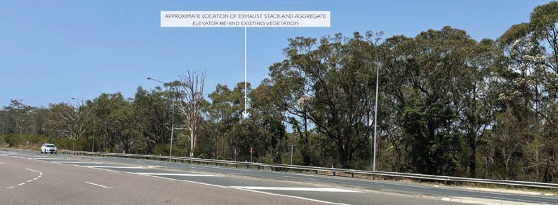
Above: View looking towards site from the off-ramp intersection of the M1 and Sparks Road (478m)

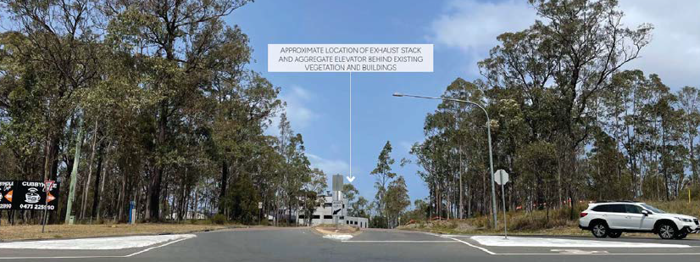
Above: View from entry to business park looking south (220m)

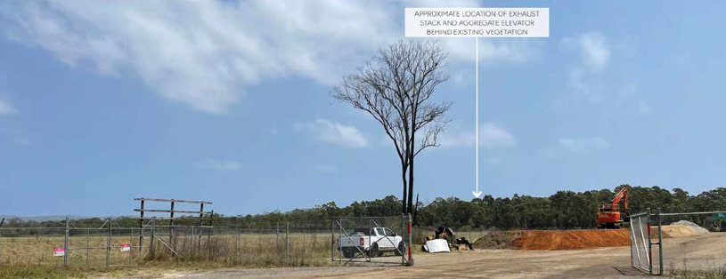
Above: View looking west towards site from corner of Sparks Road and Jack Grant Ave (1007m)

The DCP contains a number of controls for building design and appearance to ensure that development is visually sympathetic and has a positive aesthetic appearance to the streetscape. These controls are not directly applicable to the development comprising mainly plant and in this regard it is noted that the site will be screened to the street and adjoining properties by landscaping and acoustic walls.

The DCP requires outdoor storage areas to be visually screened and the proposal achieves this. The other matters outlined under the DCP have been addressed under the proposal.

• CCDCP Chapter 2.13 – Transport and Parking

CCDCP Chapter 2.13 – Transport and Parking does not nominate any specific parking requirements for an asphalt batching plant or waste or resource management facility and the generic parking rate that applies to industrial and office floor space is not relevant given the limited floor space proposed and nature of the use.

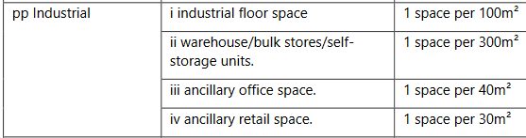

On this basis, parking demand is assessed on its merits. The DCP relies on floor area as a measure for the intensity of a land use and its corresponding parking demand, however, this is not an appropriate measure of parking demand for the proposal.

The proposal included the provision of 9 parking spaces. Five of these are located adjacent to the proposed office and laboratory and the remainder are located in the south-eastern and southwestern corner of the development footprint. One accessible parking space is needed and this has been provided.

The arguments for the adequacy of the parking provision from the applicant are as follows:

There are 10 (FTE) employees for plant operation as well as 5 FTE truck drivers which totals 15 FTE employees. The site will operate 24 hours a day and 7 days a week with peak production and delivery times anticipated to occur between 7am to 2pm and 8pm to 1am. Having regard for the 24-hour operation and the peak production and delivery times, and the need for a spread of plant operation employees over 3 shifts per day, the number of plant operation staff on site at any time is 5. Sufficient parking is provided by the 9 spaces for the workers and for the increase in workers on site during transition between shifts.

In relation to the 5 FTE truck drivers, the plant will generally not require the parking of heavy vehicles on site for extended periods. The parking of private vehicles by truck drivers at the beginning of shifts will occur at the Tomago Asphalt Plant and other locations but not at the Warnervale site. The Warnervale Plant will be a pickup point and a drop off point for materials transported by the heavy vehicles during each shift. The 9 spaces on the site is sufficient for the anticipated number of plant operation staff (3 shifts per day) and for the anticipated number of truck drivers, noting trucks in general will originate and terminate at other locations.

Overall, the parking arrangements are considered adequate for the development and consistent with the objectives for the DCP Chapter.

• CCDCP Chapter 2.14 Site Waste Management

In accordance with DCP Chapter 3.1, the applicant submitted detailed construction and operational Waste Management Plans for the development outlining the waste disposal, re-use and recycling (on and off site). These plans for the construction and operational stages of the development include a description of how waste would be handled, processed, and disposed of, or re-used or recycled, in accordance with the SEARs and Central Coasts requirements. A condition has been included requiring the development to be carried out in accordance with the submitted management plan.

• CCDCP Chapter 2.15 – Signage and Advertising

The proposed development seeks approval for new identification signage associated with the development comprising a 5m x 3m flush wall sign depicting the name of the business operating at the site. The sign is proposed in the centre of the north-east wall of the product storage bins.

In accordance with Chapter 2.15, the wall signage relates to the approved use of the land upon which it is located. The signage is consistent with the objectives under Clause 2.15.2 for business and building identification signage and is generally consistent with the requirements for wall signage under Clause 2.15.2.2.

Contributions Plans

The following contributions plans are relevant pursuant to Section 7.18 of the EP&A Act and have been considered in the recommended conditions (notwithstanding Contributions plans are not DCPs they are required to be considered):

- Warnervale District Section 7.11 Contributions Plan

The Warnervale District Contributions Plan has been considered and the following contributions are applicable: ‘Plan prep & admin’ and ‘Transport Land & works’. The contributions are levied in accordance with the plan and will be imposed as a recommended condition.

- Housing and Productivity Contribution plan

The development is also subject to a contribution under the NSW Government Housing & Productivity Scheme. A condition will be included under the recommended conditions should the application be supported.

  - Section 4.15(1)(a)(iiia) – Planning agreements under Section 7.4 of the EP&A Act

There have been no planning agreements entered into and there are no draft planning agreements being proposed for the site.
  - Section 4.15(1)(a)(iv) - Provisions of Regulations

The matters that must be taken into consideration by a consent authority in determining a development application under Sections 61-68 have been considered and there is no specific discussion required.
Section 4.15(1)(b) - Likely Impacts of Development

The likely impacts of that development, including environmental impacts on both the natural and built environments, and social and economic impacts in the locality must be considered. In this regard, potential impacts related to the proposal have been considered in response to SEPPs, LEP and DCP controls outlined above and the Key Issues section below.

The consideration of impacts on the natural and built environments includes the following:

Stormwater
Stormwater runoff from paved areas will be managed through a new in-ground pipe drainage network discharging into a sediment basin located at the rear of the site. Stormwater pits will be fitted with a filtration system for regulation of water quality. Run off from roofed areas will be directed to rainwater tanks via a first flush device with the overflow connected to the in-ground piped network. Subsoil drainage lines will be installed behind kerbs, along road edges and within landscaped areas and will connect to the stormwater management system. The bunded diesel storage area will not connect to the stormwater network but will be bunded to confine any spills to within the containment area.
The detail engineering design to be undertaken during the Construction Certificate will need to identify the requirements for vehicle access to this Council stormwater and sewer infrastructure, in conjunction with the proposed location of retaining walls and acoustic fencing.
Concept stormwater drainage plans were submitted by MPC Consulting Engineers. Post developed stormwater flows will be managed so they do not exceed existing stormwater runoff rates. Water quality will be managed through a treatment train. Stormwater drainage pipes and kerb inlet pits are proposed along the northern and southern boundaries, that connect to a stormwater drainage pipe that runs along the rear boundary. This stormwater drainage pipe connects into a proprietary gross pollutant trap (GPT) before discharging into an onsite detention (OSD) basin. Stormwater pits throughout the site are proposed to have Ecosol litter baskets. Rainwater tanks are proposed to be connected to some of the roof areas of buildings and/or sheds.
The OSD basin is proposed to have 315 m³ of storage volume. This will manage flows from the 20% AEP to the 1% AEP design flood events.
A Preliminary Plan of Management was submitted for the stormwater detention basin. This includes the use of vacuum trucks for the GPT, OSD basin, and the use of a crane to lift a skid steer loader into the OSD basin. A single pedestrian access has been provided into the OSD basin at approximately halfway along the structure. It is recommended that a second pedestrian access is included towards the rear of the structure (southern-eastern section of the site). Given the pollutants that are expected to arrive at the GPT and OSD basin, regular maintenance should be undertaken on all stormwater drainage water quality infrastructure, as well as periodic/ reactive maintenance after rainfall events.
Earthworks
A geotechnical investigation was undertaken with 6 boreholes dug throughout the site. This investigation indicates the site is covered with fill to a depth of about 0.6m below the existing ground level, below which is clay like material, with bedrock found at depths lower than 2 metres, in two of the boreholes. This site is not impacted by Acid sulphate soils.
The earthworks, structural engineering and detailed engineering design for the development, should use the information contained in this geotechnical investigation. The report includes a site classification based on the geotechnical investigations, recommendations for foundations and earthworks, pavement design and drainage and subgrade preparations. There are a number of council owned sewer and stormwater assets that may be impacted by the proposed earthworks and retaining walls on this site, so the recommendation for footings and foundations in close proximity to these assets should be read in conjunction with Council’s Building in Proximity to Water and Sewer Pipelines Policy and Procedure.
The applicant should also ensure the final version of the site-specific geotechnical investigation report is used for design purposes, the version submitted as part of this DA assessment is noted as draft.
There are a number of retaining walls proposed throughout the site, varying in height from 0.4 to almost 4 metres in height. Some of these retaining walls are proposed along the northern and southern boundary, and some are through the site in a more north-south orientation. All retaining walls over 0.6 metres in height or those subject to significant loads shall be designed by a suitably qualified structural engineer and be based on the site-specific geotechnical investigation. The retaining wall design must not conflict with existing or proposed services or utilities.
Roads, Access, Traffic & Parking
The proposal was accompanied by an updated Traffic Impact Assessment which identified that the proposal would generate additional (worst case) traffic in the order of 42 inbound and 42 outbound heavy vehicle trips as well as 15 inbound and 15 outbound light vehicle trips during operation. This is a total of 30 light vehicle trips and 84 heavy vehicle trips per day generated by the operations of the development. Heavy vehicle traffic will be spread across 24 hours and light vehicle (staff) traffic will be spread across 3 shifts. Satisfactory sight distances are available at the access along Warren Road. The report concludes that intersections in the vicinity of the site will continue to perform satisfactorily during the operation of the development on the site.
Transport for NSW provided comment on this development application and have not raised any concerns or have specific conditions of consent for this development. No footpath will be required as part of this development given the industrial context of the site.
Two vehicle access crossing (VAC) are proposed as part of this development application, one on the northern and one on the southern side of the development boundary at Warren Road. The northern VAC will be used for entry only, and the southern VAC for exit only. Each VAC will have a 10 metre wide gate. The VACs will need to be designed and constructed in accordance with Council’s Civil Works Specification 2020 (CWS) Standard Drawings and CCDCP. The driveway profiles are considered satisfactory for the design vehicles.
Swept path analysis was provided for 19m articulated semi-trailer and B-Double vehicles in and around the site. This analysis shows that there is adequate space available on the site for these vehicles to enter and exit in a forward direction. The project proposes the removal of all parking spaces between the two vehicle access crossings to enable safe B-Double (26m long) movements. This will need to be separately approved by the Traffic committee.
Water & Sewer
There is a 200mm UPVC water main that runs along the southern road reserve side of Warren Road. There is an existing 150mm VC sewer main that runs along the southern boundary of the neighbouring property at 5 Warren Road. There is a sewer manhole (labelled ND05) approximately halfway along this boundary and one in the rear of the lot of 5 Warren Road. This sewer main then runs in a north-westerly direction along the rear boundary of number 3 Warren Road. There is a sewer manhole (labelled NHA01) approximately halfway along this rear boundary. This connects into the sewer main that runs along the rear of the properties along the northern boundary at manhole labelled NH03A. The retaining walls proposed along the northern and southern boundaries will need to ensure they are designed and constructed in accordance with the requirements of Council’s Building in Proximity to Water and Sewer Pipelines Policy and Procedure even though this sewer main is located on the neighbouring property.
The development will require a Section 305 application to be submitted to Council under the Water Management Act 2000 for a Section 307 Certificate to be issued upon completion of works. Water and sewer contributions are required for this proposal, which will be detailed on the WMA Section 306 Requirements letter.
Construction Issues – Parking, traffic, Existing Infrastructure, Neighbouring Properties – Dilapidation
Standard conditions will be required to be included on any consent to be issued for the development for the preparation and documentation of dilapidation reports on Council assets and neighbouring properties. Suitable Construction Traffic Management plans will be required to ensure the safety of all road users. These are included as a recommended condition of consent.
Waste
The asphalt batching plant is designed to provide for the use of RAP milled during road works and therefore will reduce the waste going to landfill. The opportunities to increase recycling materials including plastic, glass and rubber.
A Construction Waste Management Plan and an Operational Waste Management Plan were prepared for the proposal in accordance with the Waste Avoidance and Resource Recovery Act 2001. Most waste during construction activities would be categorised as building waste within the general solid (non-putrescible) classification. During the operation, the waste generation incorporates waste from the asphalt batching process, site management and maintenance, and general waste. The submitted waste management plans included best practice mitigation and management measures through re-use, recycling and disposal of waste streams.
Fire Management
The risk of potential fire hazard in the operation of the plant is minimised by the use of automatic sensing and temperature control along with automatic or semi-automatic shut-down procedures. The ignition of bitumen by localised heating above the ignition temperature, in the presence of oxygen can occur in the bitumen tank during preheating or within the mill when it is being added to the pre-heated aggregate. Additionally, adequate firefighting equipment will be installed within the plant to provide protection in the event of a fire. A blue smoke extraction system is to be installed to minimise blue smoke emission discharge from the tops of silos and at truck loading areas.
Air Quality
The applicant submitted an Air Quality and Greenhouse Gas Assessment for the proposal which assessed relevant potential air pollutants associated with construction and operational activities. The Air Quality Impact Assessment assessed the potential air quality impacts associated with the proposal and identified mitigation measures. The detailed modelling identified no exceedances of the incremental criterion for dust deposition predicted at any of the receptors.
The report identified that the operation of the proposal is unlikely to cause any odour nuisance at any surrounding receptors. The overall air quality risk from the proposed construction activities is rated as low for the surrounding industrial receptors and the mitigated dust deposition and human health impacts are both anticipated to be negligible. The report recommends:
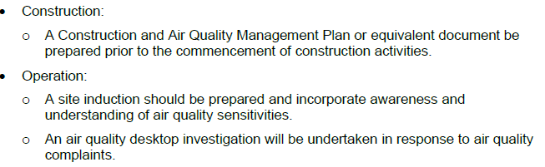
Further information was provided in relation to dust emissions during construction (bulk earthworks for sediment basin construction, stockpiling of soils and hardstand construction) and Council’s relevant expert is satisfied - subject to the proposed mitigation measures and recommended conditions - that the proposal will not adversely impact on air quality. The site will be subject to an Environmental Protection Licence (EPL) which will have air quality conditions placed on it. Conditions for air quality will be limited due to EPL and EPA being the ARA.

Noise and vibration
The development is proposed to operate 24 hours a day, seven days a week. A Noise and Vibration Impact Assessment was prepared and assessed for the proposal to assess the potential construction and operational noise and vibration impacts associated with the development.

The report identified potential noise impacts associated with the proposal related to construction noise, operational noise, vibration, cumulative noise, sleep disturbance, plant and equipment noise and traffic noise. Variable aspects such as weather conditions were also included in the assessment.

The acoustic report identified mitigation and management measures for both during construction and ongoing operation. The operation of the development on the subject site will require issue of an Environmental Protection Licence (EPL) from the NSW EPA and therefore imposition of ongoing noise conditions are limited as the EPL will cover these. The assessment concluded that construction noise levels are predicted to be below the relevant noise management levels at all residential receivers with low impacts expected at adjacent industrial receivers during the initial construction works phase.

Vibration levels from construction and operation are predicted to be significantly below the relevant criteria for cosmetic damage criteria, human comfort and human perception at all residential receivers. At times during construction, it is anticipated that vibration intensive workings may take place within the cosmetic damage criteria of the adjacent industrial receivers. Reasonable and feasible vibration measures during construction have been recommended.

Predicted increases in road traffic noise during both construction and operation on the surrounding road network are predicted to be significantly less than 2dB and are unlikely to be discernible. The report concludes that the proposed development is expected to comply with the Project Noise Triggering Levels at all receivers during all defined periods under NSW Noise Policy for Industry (NPfI) (2017), under both standard and noise enhancing weather conditions. Notwithstanding this, best practice noise mitigation and management strategies will be implemented to minimise any potential noise impacts.

A 3.6m high acoustic fence has been included on the plans to minimise noise impacts extending alongside the side and rear boundaries (panel fence with variable setback) and 10m from the front boundary in the form of a building wall. It is noted that the acoustic report had recommended a minimum of 2m high acoustic wall. ModularWalls (or similar product) will be used for the acoustic (side and rear) panel fencing and are designed and manufactured using a lightweight inner core and a fibre cement outer skin. The inner core works to absorb sound vibrations thereby reducing noise pollution. The fencing will not have any gaps between fencing panels and will have a surface density of a minimum 12.5kg/m².

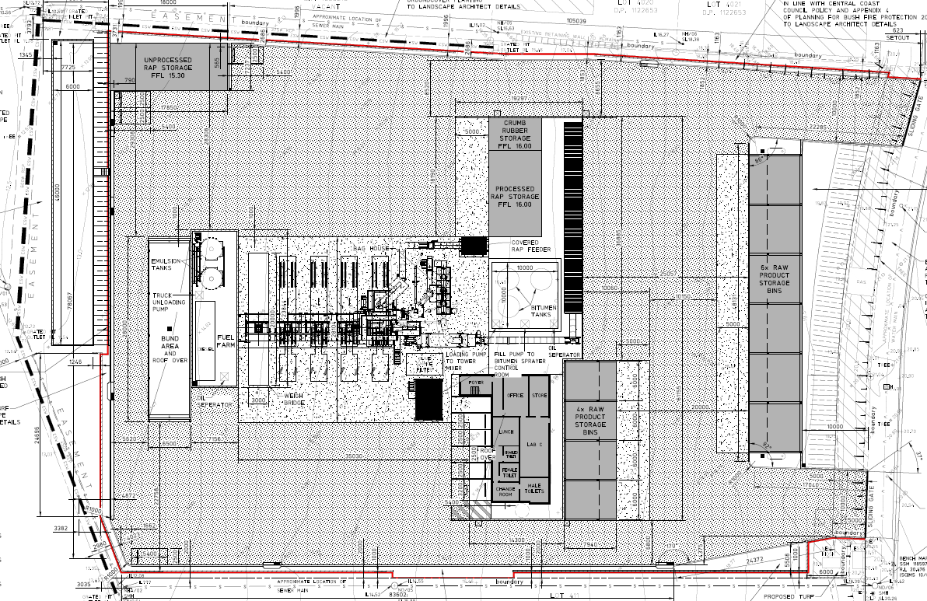
Above: Plan of site showing the proposed acoustic wall (3.6m) shown in red.

Tree Removal

The site has been cleared of most trees and vegetation under an earlier consent DA/1344/2017. The existing approvals required only three (3) trees to be retained at the rear of the site, and four (4) along the frontage. One of these 4 trees along the frontage now needs to be removed for the second driveway.

A replacement street tree of the same native species is to be replanted on the nature strip as shown in the Amended Tree Retention Plan / Landscape Plan. Street trees 1-3 are to be protected by fencing as conditioned. Trees 69, 70, 72 located at the rear of the property are to be protected with fencing as conditioned. A condition will be recommended for additional tree planting (spotted gum) in this area for further screening of the site.

Crime Risk Assessment - Safer by Design

A Crime Risk Assessment was prepared and submitted for the development which identifies and assesses the crime risk associated with the proposal, in order to provide design solutions to maximise safety during construction and operation of the development.

Natural Surveillance: The proposal includes entries with clear sightlines to maximise natural surveillance with building openings designed to be unobstructed. Appropriate directed external lighting of parking and corners so as to avoid nuisance impacts but prevent concealment and shadowing. The development will also incorporate CCTV cameras.

Access Control: A clear differentiation of public and private areas on the site with restricted access to specific areas. Installation of a monitored intruder alarm system. Locks on all doors to buildings. The 24 hour operation of the site will limit any opportunities for after-hours crime. Directional signage will direct movement around the site.

Territorial reinforcement: Perimeter fencing and locked gates and landscaping to clearly delineate public and private areas. Adoption of signage and lighting to reinforce site ownership and management.

Space Management: Maintenance and management of all landscaping and structures. Any vandalism and graffiti is to be promptly repaired.

The proposal has been designed to address the four principles under ‘Safer-by-design’ and has suitably minimised any opportunities for crime within the design and operation of the development.

Aboriginal heritage

An Aboriginal Heritage Inventory Management System (AHIMS) search was undertaken for the site indicating no recorded aboriginal objects or places near the site. There are 4 recorded sites within 1 km of the land, however none of these were recorded within 200m of the land. A search of the Register of Native Title Claims and the National Native Title Register was also made. Although the proposal will involve ground disturbance in the form of earthworks for the development, it will not involve the disturbance of any known culturally significant sites, artifacts or modified trees.

There are no significant or notable landscape features on the site or site characteristics that are often associated with aboriginal objects that may indicate the presence of potential aboriginal objects (ie. cliff face, rock shelters/ cave mouth, headland, ridgetop or ridgeline, sand dunes, waterways, waterholes and wetlands). The site is within a disturbed area for urban settlement and as such is considered to be a low impact activity (under Clause 7.5(4) having had a history of disturbance and land usage. Conditions will be recommended if any evidence of aboriginal cultural heritage is discovered on the site during construction that works must cease and the Office of Environment and Heritage must be advised.

Bushfire Hazard

The subject site is identified as part bushfire prone land and the development application was accompanied by a Bushfire Assessment Report identifying how the development will comply with Planning for Bushfire Protection 2019. The site is largely cleared with a wide sealed road frontage, with good public road access to Sparks Road and the freeway. A defendable 30m wide Asset Protection Zone exists for the development in the form of Warren Road. The site is serviced by reticulated water and fire hydrants with adequate water supply pressure available and underground power. The buildings will be constructed from non combustible materials and subject to NCC fire safety measures. The bushfire risk will be managed through implementation of a Bushfire Emergency Management Plan. The report concludes that the development will comply with the aims and objectives for Planning for Bushfires Protection 2019 subject to specified recommendations (under Section 7 of the bushfire report).

The application was referred to NSW Rural Fire Service under Section 4.14 of the EP&A Act 1979. The RFS have granted general conditions to be included with any consent to be granted.

Overall impacts

Accordingly, it is considered that subject to mitigation measures and management the proposal will not result in any significant adverse impacts in the locality as outlined above.

  - Section 4.15(1)(c) - Suitability of the site

The site is positioned within an established industrial business park and is suitably zoned for a general industrial use. There is no nearby residential receiver that would be potentially adversely impacted by the proposal. Access to the motorway and Sparks Road for heavy vehicles is a very close distance to the site.

Suitable visual landscaped screening and acoustic attenuation measures are proposed around the boundaries of the site to mitigate potential impacts. The proposal will not adversely impact on the character and amenity of the locality or streetscape. The site is considered to be in a suitable context for the nature, scale and type of development proposed. Although the site is bushfire prone land, the development has been suitably designed to accommodate this as a constraint. There are no significant site constraints or hazards that would render the location of the development as unsuitable.

  - Section 4.15(1)(d) - Public Submissions

These submissions are considered in Section 3.11 of this report.

  - Section 4.15(1)(e) - Public interest

There are no matters associated with the proposal that are contrary to the local or community interest. The proposal is consistent with the broader strategic planning objectives to provide more industrial land uses in suitable locations to support the continued growth and development of the Central Coast and lower Hunter area.

  - Agency Referrals and Concurrence

The development application has been referred to various agencies for comment/concurrence/referral as required by the EP&A Act and outlined below in Table 5.
There are no outstanding issues arising from these concurrence and referral requirements subject to the imposition of the recommended conditions of consent being imposed.

Table 5: Concurrence and Referrals to agencies
Agency | Concurrence/  referral trigger | Comments  (Issue, resolution, conditions) | Resolved
Concurrence Requirements (s4.13 of EP&A Act)
N/A
Referral/Consultation Agencies
NSW Rural Fire Service (RFS) | S4.14 – EP&A Act  Development on bushfire prone land | Recommended conditions provided by RFS (3 Jan 2024) | Y
Ausgrid | Section 2.48 – SEPP (T&I)  Development likely to affect an electricity transmission or distribution network | Ausgrid comments and requirements rec’d (27.1.24) | Y
Transport for NSW | Section 2.122 (Traffic Generating Development) Schedule 3 (Column 2 of the Table) – Any size Waste or Management Resource Facility with direct access to any road (generally) | Development is deemed to be traffic generating development. Transport for NSW have provided comments based on the revised Traffic Impact Assessment raising no objection to or requirements for the proposed development. | Y
Integrated Development (S 4.46 of the EP&A Act)
NSW Environment Protection Authority (EPA) | Environmental Protection Licence (EPL) required under Schedule 1 Section 34 of the Protection of the Environment Operations Act 1997 (POEO Act) | GTA’s issued by EPA on 21 May 2024.  The GTAs were issued including conditions that addressed noise limits, waste, odour, stormwater/sediment control, pollution, dust, fuel and chemical storage, monitoring, operating conditions and special conditions including the requirement. the installation of a weighbridge on the premises | Y

  - Council Referrals

The development application has been referred to various Council officers for technical review as outlined Table 6.

Table 6: Consideration of Council Referrals
Officer | Comments | Resolved
Engineering | Council’s Senior Development Engineer has reviewed the latest amended plans and reports and raise no further objection subject to conditions. | Y
Traffic | Council’s Traffic Engineering Officer reviewed the proposal and raised no objection. | Y
Water and Sewer | Water and Sewer is available to the land. Sewer relining is required between Manhole NHA01 to Manhole NHA02. Building in the Proximity of Water & Sewer Pipelines Procedure is applicable due to the Proposed Retaining wall. The applicant needs to obtain a section 307 certificate of compliance under the Water Management Act 2000. Water and Sewer contribution fees are applicable. No objection subject to recommended conditions. | Y
Environmental Protection | No objection subject to recommended conditions | Y
Ecologist | Council’s Ecologist is satisfied that the proposal is does not trigger the Biodiversity Offsets Scheme under Part 7 of the Biodiversity Conservation Act 2017, and a Biodiversity Development Assessment Report (BDAR) is not required to be submitted with the application. Council’s Ecologists has no objection to approval of the application, provided the conditions recommended by the Tree Assessment Officer are included within any consent granted. | Y
Contributions Officer | No objection subject to recommended conditions | Y
Trade Waste Officer | No objection subject to recommended conditions | Y
Tree Officer | No objection subject to recommended conditions | Y
Waste Officer | No objection subject to recommended conditions | Y

The outstanding issues raised by Council officers are considered in the Key Issues section of this report.

  - Community Consultation

The proposal was notified in accordance with the DCP Chapter 1.2 and the relevant provisions of the Act that apply to Designated Development and Advertised Development for 30 days. The advertisement of the proposal was carried out from 9 February 2024 until 12 March 2024.

The Council received no submissions in relation to the proposal.

There were no submissions received following public exhibition of the application that required forwarding to the Planning Secretary under Section 60 of the Environmental Planning and Assessment Regulation 2021 and in accordance with Section 4.16(9), for designated development.

- KEY ISSUES UNDER SEARs
The key issues identified in the SEARs (No.1780) identified the following key issues that needed to be addressed under as part of the EIS assessment.

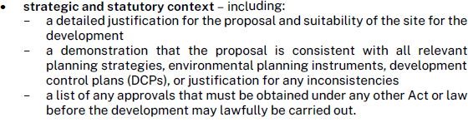
Comment:
Sections 2, 3, 4 and 7 of the EIS suitably address these requirements.

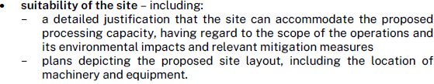
Comment:
Section 6 and 7 of the EIS and the detailed plans suitably address these requirements.

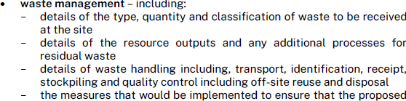
Comment:
Section 6.1 (Waste Management) and the detailed Waste Management Plans (construction and operation) under Appendix G of the EIS suitably address these requirements.

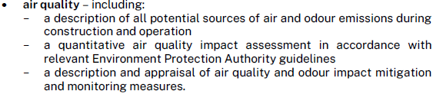
Comment:
Section 6.2 (Air quality) and Appendix H (Air Quality Impact Assessment) of the EIS suitably address these requirements.

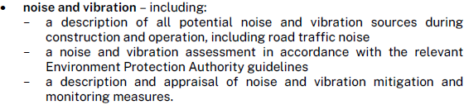
Comment:
Section 6.3 and the Noise and Vibration Impact Assessment under Appendix I of the EIS suitably addresses these requirements.

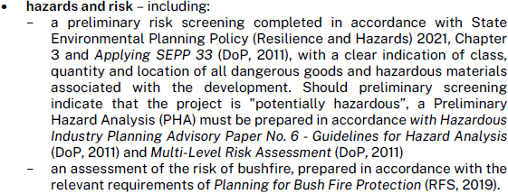
Comment:
Section 6.4 and the Hazard and Risk Assessment under Appendix J of the EIS suitably addresses these requirements.

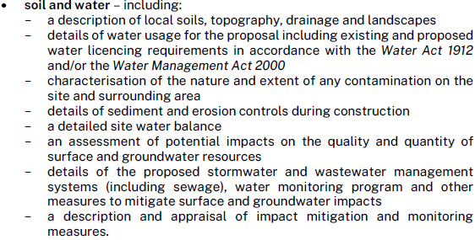
Comment:
Section 2.9 and Section 6.5 and Table 6 and Appendix L (Preliminary Site Investigation), K (Stormwater Management Report) and J (Hazard and Risk Assessment) of the EIS suitably addresses these requirements.

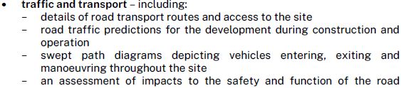
Comment:
Section 6.6 and the Traffic and Transport Assessment under Appendix M of the EIS suitably addresses these requirements.

Comment:
Sections 4.3 and 6.7 (Biodiversity) of the EIS suitably addresses these requirements.

Comment:
Section 6.8 (Visual Amenity) of the EIS suitably addresses these requirements.

Comment:
Section 6.9 (Heritage) of the EIS suitably addresses these requirements.

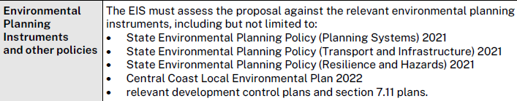
Comment:
Section 4 of the EIS suitably addresses these requirements.

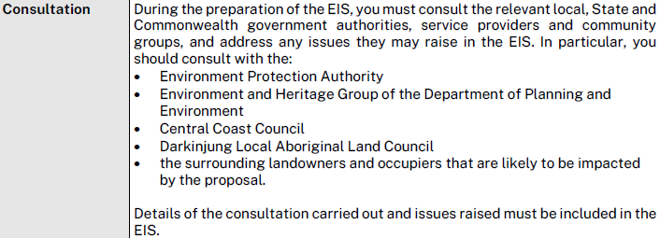
Comment:
Section 5 of the EIS suitably addressed these requirements.

The above issues identified under the SEARs have all been satisfactorily resolved under the EIS and through the plans and amended supporting information and as further addressed in the recommended conditions of consent.

- CONCLUSION

The proposal involves the construction and operation of an asphalt plant and waste or resource management facility on the site and associated works for the manufacture and delivery of asphalt products within the Newcastle, Hunter and Central Coast Regions. The proposal is identified as Designated Development and integrated Development. The proposed activity at the premises will require an Environmental Protection Licence (EPL) in accordance with Schedule 1 Section 34 of the Protection of the Environment Operations Act 1997.

The development application has been considered in accordance with the requirements of the EP&A Act and the Regulations as outlined in this report. Following a thorough assessment of the relevant planning controls, referral comments and the key issues identified in this report, it is considered that the application can be supported.

The site is considered suitable for the site and will allow for the continued growth of the area through the efficient and competitive supply of asphalt. and the proposal in its revised form is compatible with the locality.

It is considered that the key issues as outlined in the SEARS under Section 4 have been satisfactorily addressed through information accompanying the application and through amendments to the proposal and/or in the recommended draft conditions at Attachment A.

- RECOMMENDATION

That the Development Application DA/2317/2023 for the Construction and operation of an Asphalt Batching Plant (bitumen pre-mix and hot-mix facilities) and Waste or Resource Recovery Facility and associated works at 3 Warren Road Warnervale be APPROVED pursuant to Section 4.16(1)(a) or (b) of the Environmental Planning and Assessment Act 1979 subject to the draft conditions of consent attached to this report at Attachment A.

The following attachments are provided:
- Attachment A: Draft Conditions of consent
- Attachment B: Architectural and Civil Plans

